Name ________________________________
Block ________________________________
Date ________________________________
English 9 Me Poster Rubric
Once you have your abstract noun, quotation with speaker, and photo,
use these items to create your Me Poster
at http://wigflip.com/automotivator/.

_____/5 1. School appropriate, positive, correctly spelled abstract noun.
_____/5 2. Quotation exhibits correct spelling and grammar, and includes the speaker’s name.
*Line breaks are at appropriate, logical places.
_____/5 3. Quotation is obviously relevant to the abstract noun.
_____/5 4. School appropriate photo of yourself where your face is clearly visible and identifiable.
_____/5 5. Hard copy printed out in color and digital copy saved in the Me Poster folder in our class melon folder. Please save as “Your last name Me Poster.”
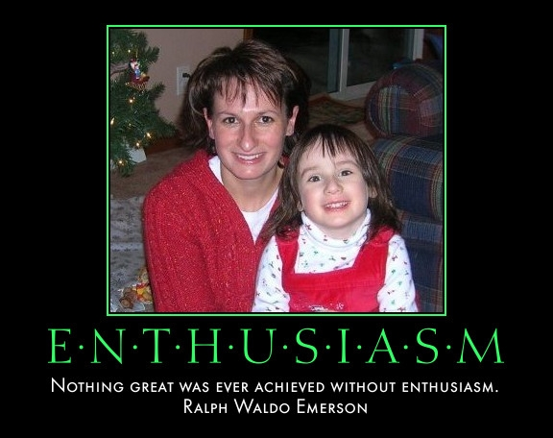
_____/25 Total Points

